**Project Documentation: Istio Service Mesh**

**Overview**

Istio is an open-source service mesh that provides a way to control how microservices share data with one another. By abstracting away the complexities of microservice-to-microservice communication, Istio simplifies service discovery, traffic routing, security, and observability, enabling teams to focus on building resilient and efficient applications.

**Key Features of Istio**

1. **Traffic Management:**
   * Fine-grained control over traffic behavior with routing, retries, failovers, and fault injection.
   * Canary releases and blue-green deployments.
2. **Security:**
   * Mutual TLS (mTLS) encryption for secure service-to-service communication.
   * Authentication, authorization, and audit (AAA) features.
3. **Observability:**
   * Detailed monitoring of service traffic with metrics, logs, and distributed tracing.
   * Integration with tools like Prometheus, Grafana, and Jaeger.
4. **Policy Enforcement:**
   * Apply custom policies to enforce rate limits, quotas, and access control.

**Architecture**

Istio introduces a service mesh layer by deploying two main components:

1. **Data Plane:**
   * Composed of Envoy sidecar proxies deployed alongside each microservice.
   * Handles service-to-service communication and enforces policies.
2. **Control Plane:**
   * Manages the configuration and behavior of the data plane components.
   * Key components of the control plane include:
     + **Pilot:** Service discovery and traffic management.
     + **Mixer:** Policy enforcement and telemetry collection (deprecated in newer versions).
     + **Citadel:** Handles security, including mTLS certificate issuance.
     + **Galley:** Configuration validation and distribution (replaced in newer versions).

**Installation**

**Prerequisites**

* Kubernetes cluster (v1.19 or higher recommended).
* kubectl installed and configured.
* Sufficient permissions to deploy resources on the cluster.

**Steps**

1. Download the Istio CLI:

curl -L https://istio.io/downloadIstio | sh -

cd istio-<version>

1. export PATH=$PWD/bin:$PATH
2. Install Istio on the cluster:

istioctl install --set profile=demo -y

1. Enable automatic sidecar injection:

kubectl label namespace default istio-injection=enabled

1. Verify installation:

kubectl get pods -n istio-system

**Key Concepts**

1. **Service Mesh:** A dedicated infrastructure layer for handling service-to-service communication.
2. **Sidecar Proxy:** A lightweight proxy injected into each service pod to handle networking functions.
3. **Virtual Service:** Defines rules for traffic routing.
4. **Destination Rule:** Configures policies for traffic destined to a service.
5. **Gateway:** Configures external access to services.

**Use Cases**

1. **Traffic Splitting for Canary Deployments:** Route 90% of traffic to the stable version of a service and 10% to the new version.

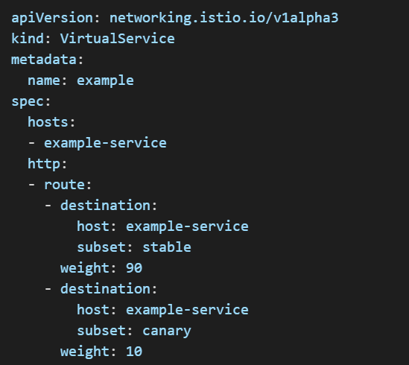

1. 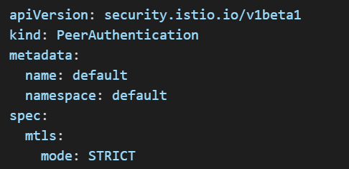**Secure Communication with mTLS:** Enable mutual TLS between services for secure communication:
2. **Observability:** Monitor traffic and service health using Prometheus and Grafana dashboards provided by Istio.

**Advantages**

* Simplifies microservice communication and management.
* Provides robust observability and monitoring.
* Enhances security without requiring application changes.
* Enables advanced deployment strategies like traffic shaping and circuit breaking.

**Challenges**

* Steep learning curve for beginners.
* Increased resource overhead due to sidecar proxies.
* Requires Kubernetes for deployment.

**Best Practices**

* Start with the demo profile for experimentation, then move to prod or custom profiles for production.
* Regularly update Istio to the latest version to benefit from new features and fixes.
* Use namespace isolation to manage sidecar injection and traffic control effectively.

**Conclusion**

Istio is a powerful service mesh that simplifies the complexities of microservice-based architectures. Its features, including traffic management, security, and observability, empower developers to build scalable, secure, and resilient applications. However, careful planning and best practices are essential to maximize its potential in production environments.